|  |  |
| --- | --- |
|  | **LIBRARY MANAGEMENT SYSTEM**  **Technical Design Document** |
| |  |  |  |  | | --- | --- | --- | --- | |  | **Prepared By / Last Updated By** | **Reviewed By** | **Approved By** | | **Name** | Aishwarya Srinath | Meraj Ahmad | Meraj Ahmad | | **Role** | Project Member | Cohort Trainer | Cohort Trainer | | **Signature** | Aishwarya Srinath | Meraj Ahmad | Meraj Ahmad | | **Date** | 3/4/2023 | 4/4/2023 | 4/4/2023 | |
|  |

Table of Contents

1.0 Introduction 3

1.1 Purpose of this document 3

1.2 Project overview 3

2.0 Solution Summary 3

2.1 Scope 3

2.2 Assumptions 3

2.3 Dependencies 3

2.4 Risks 3

3.0 Schematic Diagram 3

4.0 System Design 4

4.1 Proposed design 4

4.2 Component inventory 4

5.0 Database Design 4

5.1 Data Model 4

5.2 Tables Structure 4

6.0 Appendices 4

6.1 Glossary 4

6.2 Other 5

7.0 Terms & Conditions 5

8.0 Change Log 5

# Introduction

## Purpose of this document

The purpose of this document is to document the technical design, component details and Database design. This will also capture the scope, assumptions, risk, dependencies of this project.

## Project overview

A library management system is a software application that is designed to manage the operations of a library. The system includes a variety of features that enable librarians to manage the library’s collection of books, journals, and other materials as well as provide services to patrons.

# Solution Summary

## Scope

The system accepts the General Library Transactions of book issue, return and renewals for the members. Different areas where we can use these applications are:

* Library resources can be easily viewed.
* Provide the list of books the users can borrow.
* Any educational institutes can make use of it for providing information about author, content of the available books.
* The system would provide basic set of features to add/update members, add/update books, and manage check in specifications for the systems based on the client's statement of need.
* A status page for all users to view books borrowed by them, their individual due dates and their individual penalties if any.

## Assumptions

1. **Resources Assumption.**

The resources assumption of a library management system includes the availability and allocation of resources required for the development, implementation, and maintenance of the system. It may include hardware, software, staffing and support.

1. **Technology Assumption.**

Technology-based assumptions create a framework of the tech infrastructure required to meet project goals. Technology resources may include Operating system, network infrastructure, database management system, mobile technologies and more. Tech is usually internal but could be outsourced, so it's important to be very aware that the reliability of any outsourced resources could be affected by the availability, capabilities and procedural difficulties that could occur. Identifying these possible constraints allows you to prepare a contingency plan in case any of these problems occur internally as well.

1. **Time-Based Assumption**.

These potential limitations, also known as scheduling assumptions, are often affected by the availability of critical resources like technology, project members. Again, it's recommended that we have built-in contingencies to buffer any lack of resources that can significantly impact on our project timeline.

1. **Quality /Specification Assumption**.

Quality assumptions can impact a project schedule if the standard of quality is lacking, causing the work to need to be redone. Safety guidelines play a role, too, when your team is required to adhere to certain specifications, in which there is no room for error and any small divergence from specifications can impede the success of the project.

1. **Local / Environment Assumption.**

These assumptions involve the location in which the work will take place and the environmental conditions under which it's performed. A project can be negatively affected if incorrect assumptions are relied upon and the projected location changes. Assumptions play an essential role in developing a risk management plan. The project should be completed successfully, on time.

## Dependencies

## Front-end development frameworks: Angular/React is used for frontend.

## Back-end development frameworks: Spring Boot is used for backend.

## Database management systems: MySQL is used for databases.

## Risks

* **Technical Risks:** Technical risks associated with the development, implementation, and maintenance of the library management system include system downtime, software bugs, and hardware failures.
* **Change Management risk:** The implementation of a new library management system may require changes in organizational policies and procedures, leading to resistance and confusion among library staff. To mitigate this risk, change management strategies and communication plans must be developed.
* **Data Security risks:** The library management system may contain sensitive information about library users and resources, making it a potential target for cyberattacks or data breaches. To mitigate this risk, appropriate security measures such as encryption, firewalls, and user access controls must be implemented.

# Schematic Diagram

A schematic, or schematic diagram, is a representation of the elements of a [system](https://en.wikipedia.org/wiki/System) using abstract, graphic [symbols](https://en.wikipedia.org/wiki/Symbol) rather than realistic pictures. It gives an overview of the overall system.

# System Design

## Proposed design

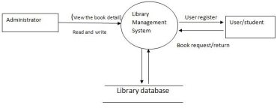

## Component inventory

*The components of the project will be,*

* *Librarian*
* *Patron*

# Database Design

## Data Model

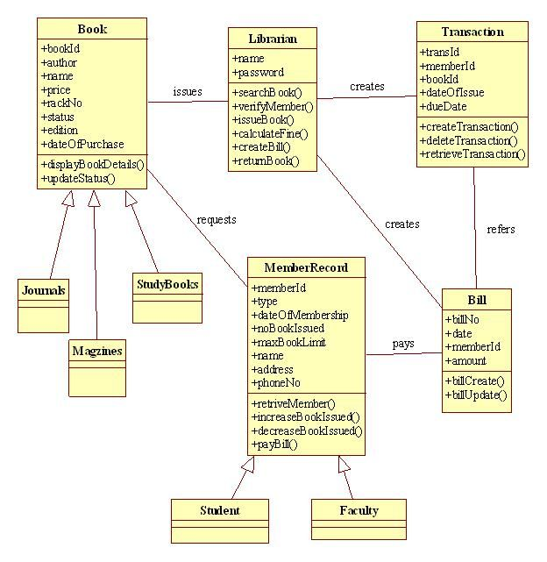

## Tables Structure

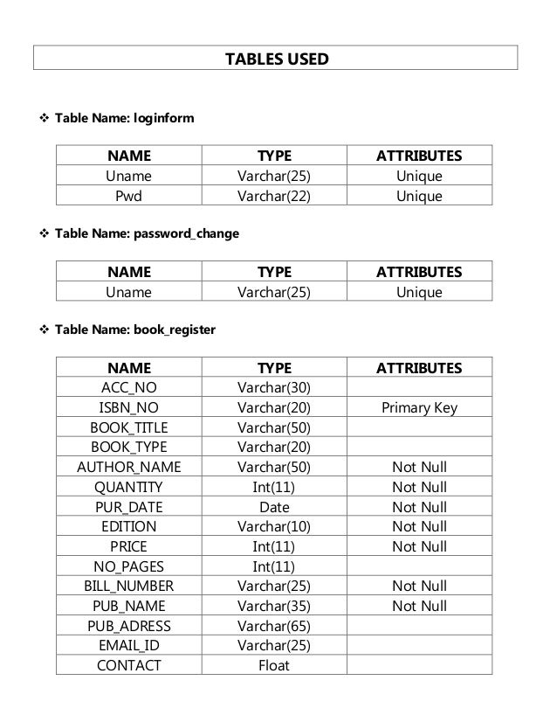

# Appendices

## Glossary

|  |  |
| --- | --- |
| **Acronyms** | **Definitions** |
|  |  |

## Other

# Terms & Conditions

***Disclaimer: Please do not circulate or distribute this document outside of Cognizant Network, We have a Zero Tolerance Policy. Kindly adhere to 100% Compliance at all times.***

# Change Log

*Please note that this table needs to be maintained even if a Configuration Management tool is used.*

|  |  |  |  |  |
| --- | --- | --- | --- | --- |
| Version Number | Changes made | | | |
| V<n.n> | *<If the change details are not explicitly documented in the table below, reference should be provided here>* | | | |
| Page no | Changed by | Effective date | Changes effected |
|  |  |  |  |
|  |  |  |  |
|  |  |  |  |
|  |  |  |  |